# Caremark.com – Unauthenticated Homepage and Content

Caremark.com Unauthenticated Homepage

Content Pages – Caremark.com

Your Questions, Answered

Footer

Related Documents

**Description:** Covers Caremark.com Unauthenticated Homepage, Content Pages, and features.

|  |
| --- |
| Caremark.com Unauthenticated Homepage |

**Benefits:**

* Mobile-friendly content educates members on digital tools and services available to them on Caremark.com.
* Allows for an easy-to-follow path on actions members can take to manage their prescriptions, understand their plan benefits, and find savings opportunities on prescriptions.
  + Members can click **Register** located at the top right orclick **Get started with CVS Caremark:** Link provided that directs members to register for an account/Registration page.
  + Members can click **Sign in** located at the top right or click **Sign into your CVS Caremark account:** Directs members to the Sign in page.

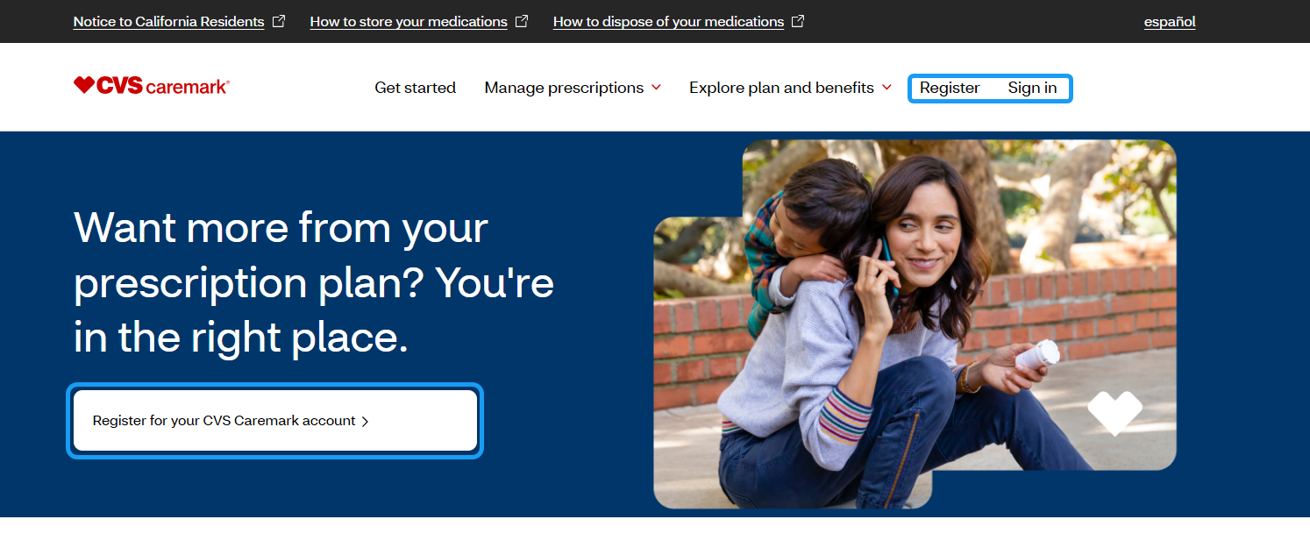

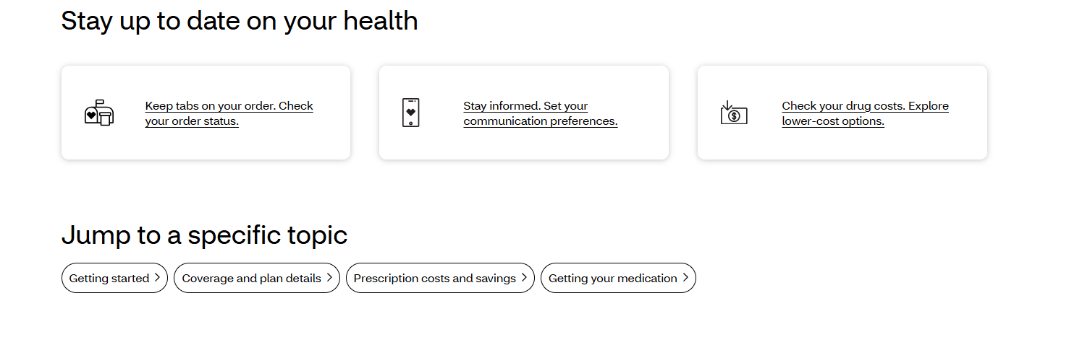

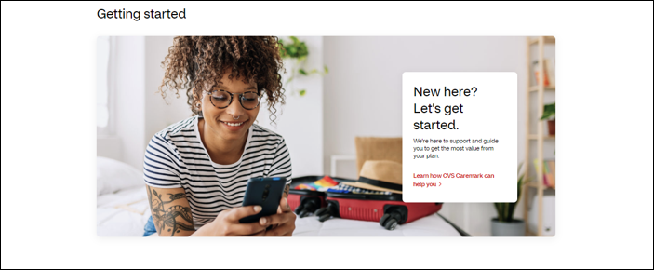



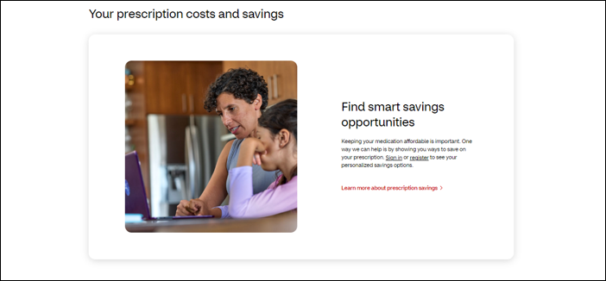



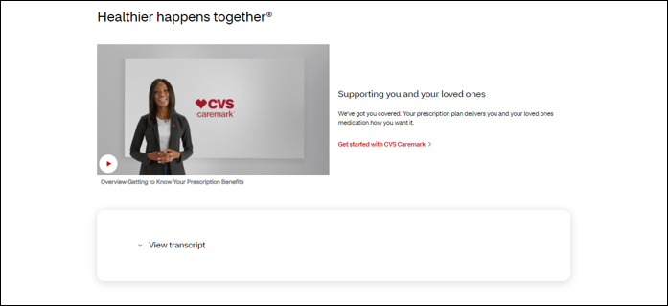





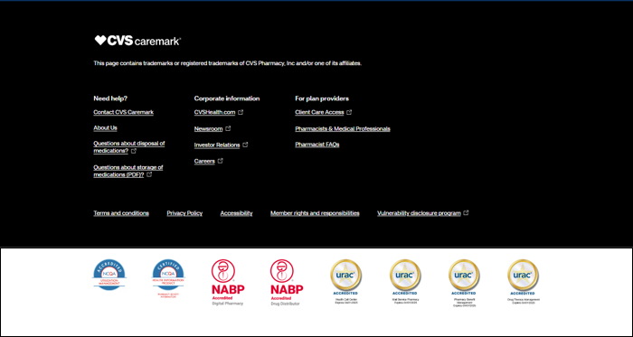

Top of the Document

|  |
| --- |
| Content Pages – Caremark.com |

**Overview of Content Pages:**

* **Stay up to date on your health**



* **Getting started –** Click the link to **Learn how CVS Caremark can help you.**



* **Your coverage and plan details.** Click the link to **Learn more about your plan.**



* **Your prescription costs and savings.** Click link to **Learn more about prescription savings.**



* **Getting your medication:** Click the link to **Review option for getting your prescriptions.**

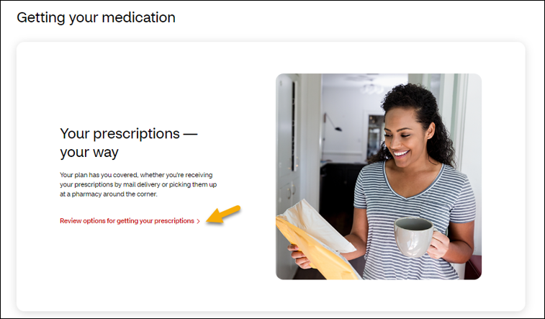

* **Healthier happens together:** Click the link to **Get started with CVS Caremark.**



* **Health resources at your fingertips.** Stay informed about your health with the latest information on generic drugs, advice from licensed pharmacists, and up-to-date drug safety alerts.



Top of the Document

|  |
| --- |
| Your Questions, Answered |

Links available direct members to the **Help Center** or **Click Visit our help center.**

* **Prescription** **Management**
  + Order status and history
  + Ordering prescriptions
  + Medication use and safety
* **Account Management**
  + Cost and coverage
  + Payments and billing
  + Web and account support



Top of the Document

|  |
| --- |
| Footer |

**This page contains trademarks or registered trademarks of CVS Pharmacy, Inc and/or one of its affiliates.**

Links available for the following:

* Need help?
  + Contact CVS Caremark
  + About Us
  + Questions about disposal of medications?
  + Questions about storage of medications?
* Corporate information
  + CVSHealth.com
  + Newsroom
  + Investor Relations
  + Careers
* For plan providers
* Client Care Access
* Pharmacists & Medical Professionals
* Pharmacist FAQs
* Need Help?
  + Contact CVS Caremark
  + About Us
  + Questions about disposal of medications?
  + Questions about storage of medications?
  + Help Center
* Terms and conditions
* Privacy Policy
* Accessibility
* Member right and responsibilities
* Vulnerability disclosure program



Top of the Document

|  |
| --- |
| Related Documents |

**Parent Document:** [CALL 0049 Customer Care Internal and External Call Handling](https://policy.corp.cvscaremark.com/pnp/faces/DocRenderer?documentId=CALL-0049)

**Abbreviations/Definitions:**  Customer Care Abbreviations, Definitions, and Terms

**Index:** Caremark.com - Work Instruction/Job Aid Index

Top of the Document

Not to Be Reproduced or Disclosed to Others without Prior Written Approval

**ELECTRONIC DATA = OFFICIAL VERSION / PAPER COPY = INFORMATIONAL ONLY**